

Name: Harsh Rawat

Semester: 2nd

**Project -2**

**Topic:**

To create a static website and deploy it using AWS services.

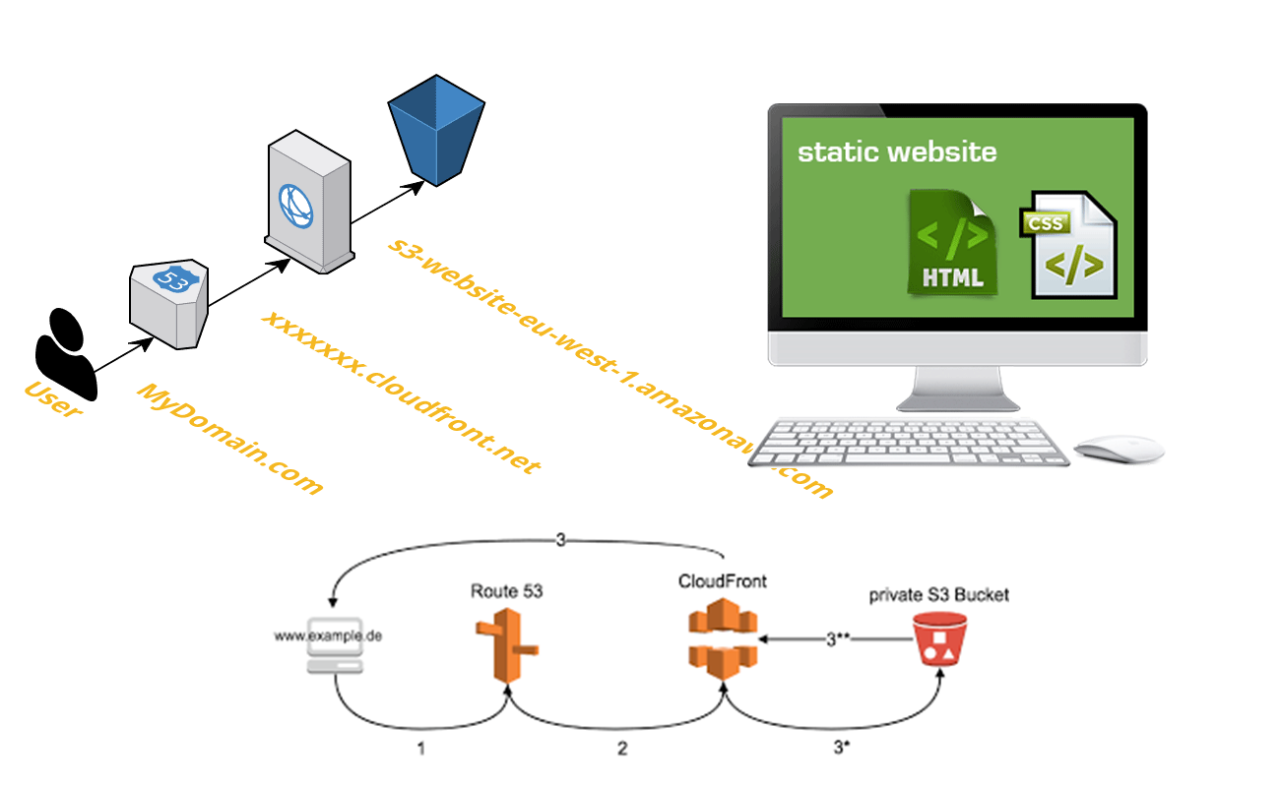

**Table of contents**

1. To create a s3 bucket
2. To enable the static website hosting
3. To edit block public access
4. To edit bucket policy
5. To upload the files
6. To copy the website end-point for testing

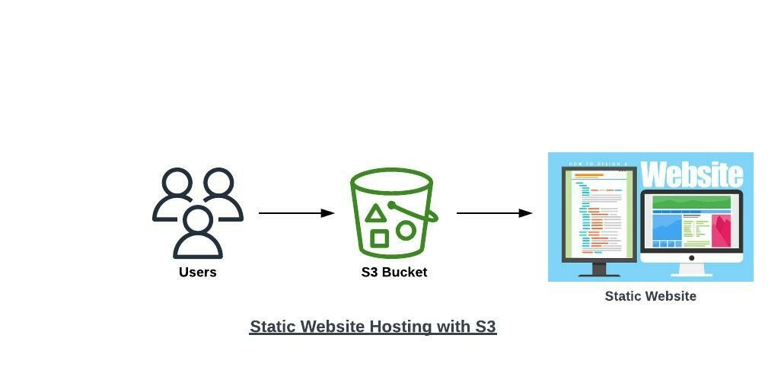

I. **To create an s3 bucket**

Firstly we create an s3 bucket for static website hosting in which we can upload our files.

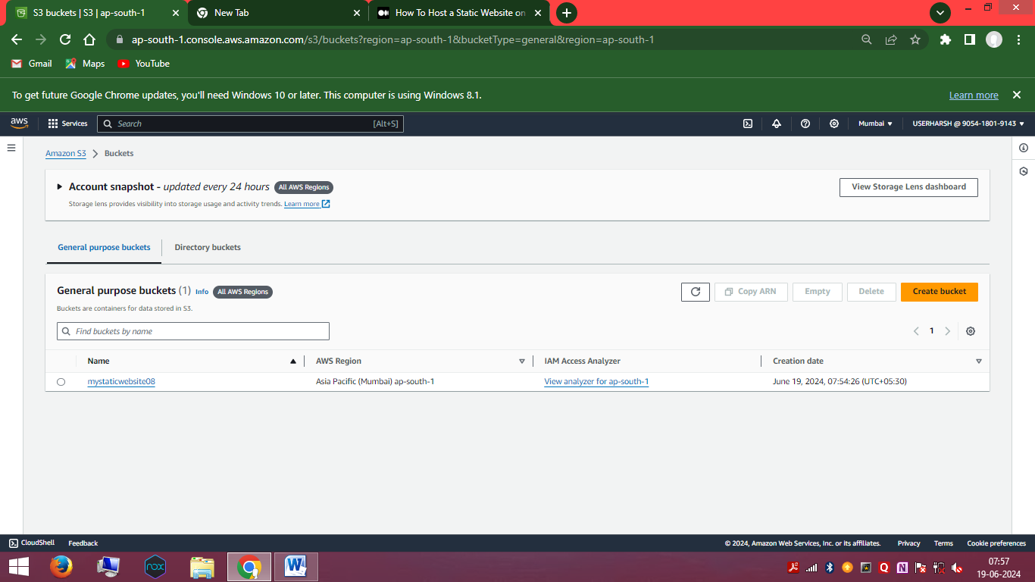

**II. To enable the static website hosting**

To enable the static website hosting

go to bucket and navigate to the created bucket.

Go to properties

And edit static website hosting situated at the bottom of the properties.

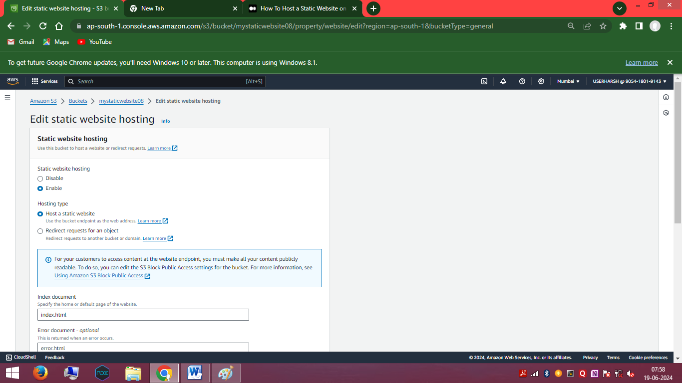

**III.** **To edit block public access**

Navigate to the permissions

And click on edit option of block public access (bucket settings)

And clear the default settings and save the changes.

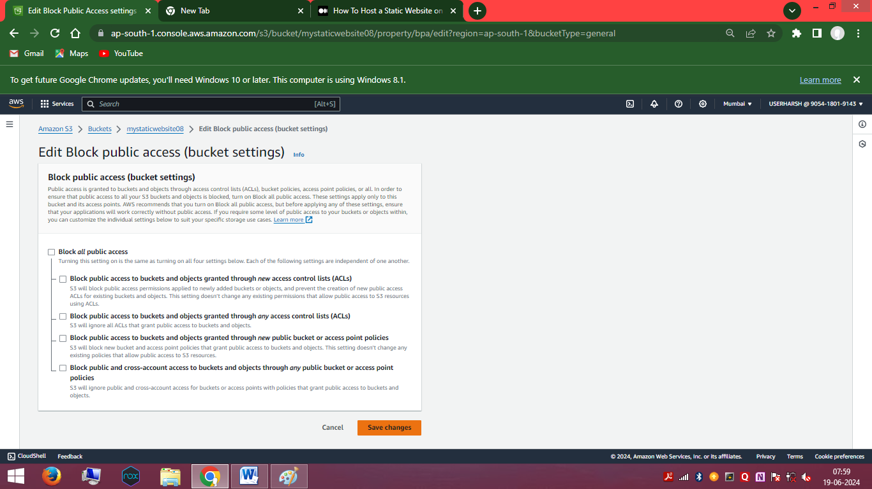

**IV. To edit bucket policy**

Now head over to the edit option of bucket policy, copy the code given below and paste it in the policy area and save the changes.

{

"Version": "2012-10-17",

"Statement": [

{

"Sid": "PublicReadGetObject",

"Effect": "Allow",

"Principal": "*",

"Action": [

"s3:GetObject"

],

"Resource": [

"arn:aws:s3:::Bucket-Name/*"

]

}

]

}

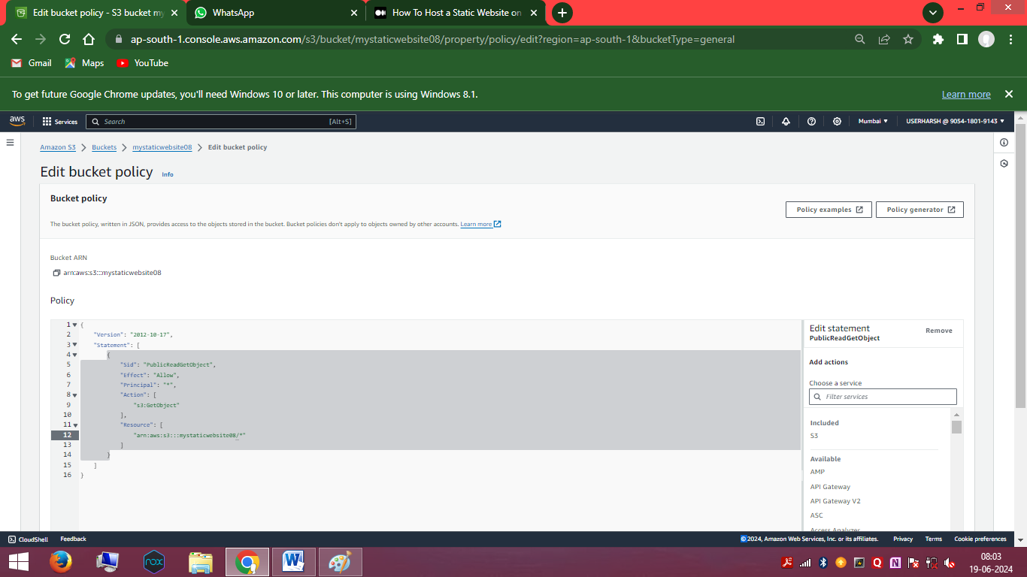

**V. To upload the files**

After creating the bucket policy, go to theobjects and click on upload option.

You have to upload the html, J, etc. files to the bucket.

And click on upload. 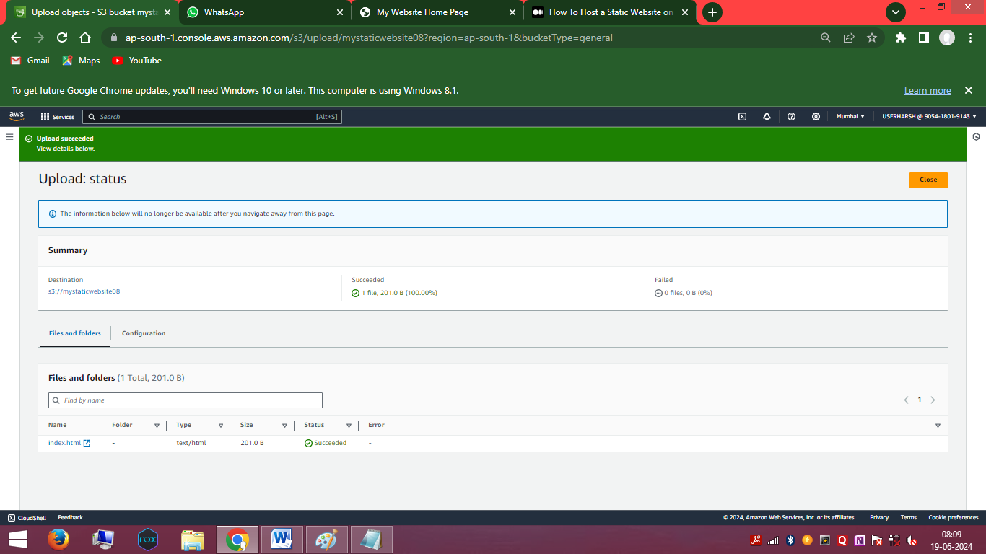

**VI. To copy the website endpoint for testing**

After completing all the steps,

Go to the static hosting option (properties)

And copy the website endpoint given below in the static hosting panel.

Head over to the browser and paste that website endpoint and

Click search.

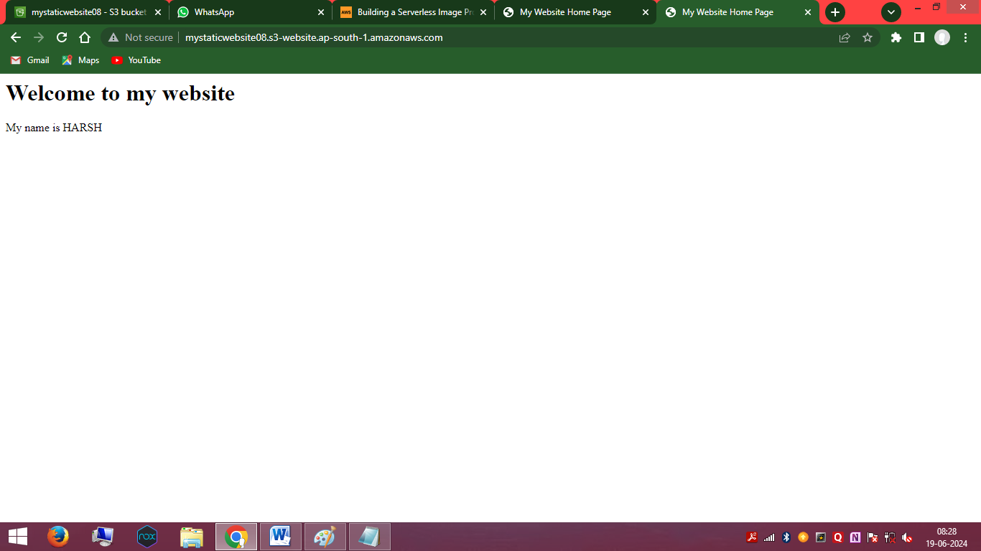

It will display like this.

Thank You!!!